*Hydrological conditions predict wood density in riparian plants of South-eastern Australia: Implications for adaptation to future human-disturbance and climate change.*

**Abstract**

Wood density is a key plant functional trait which integrates the trade-offs characteristic to riparian plant ecological strategies. We made the following predictions in this study: (1) wood density increases with frequency and magnitude of flooding disturbance (2) wood density increases as water availability in the riparian zone becomes less predictable, and (3) flooding and unpredictability of water availability induce environmental specialisation in wood density as they increase in severity. We surveyed wood density of dominant species at fifteen riparian sites along flow-gauged rivers across south-eastern Australia. Abundance-weighted site means of wood density were mapped along gradients of frequency and magnitude of flooding disturbance, and metrics of riparian water availability including baseflow index, seasonality and inter-annual variability. Metrics describing the largest, most intense flood events throughout a river’s hydrological record were found to be strong positive predictors of mean wood density. Mean wood density was also positively predicted by unpredictability of water availability in the riparian zone. This latter relationship was maximised where patterns of flow were highly seasonal, but the season with which they were associated was not consistent throughout the record. Our study highlights the importance of hydrological conditions, particularly disturbance and environmental unpredictability, as determinants of ecological strategy in riparian plants in systems dominated by extremes of flow variability and ENSO climate. This is likely to hold important ecological consequences for riparian plant communities in south-eastern Australia, where increasing climatic variability and frequency of extreme events are hallmarks of climate change predictions.

**Introduction**

Functional trait oriented approaches to understanding community assembly (McGill, et al. , 2006) have been *de mode* over the last decade, especially in plant ecology (Kattge et al., 2011). These approaches attempt to understand community assembly processes by linking morphological or physiological attributes of species to organismal success under given environmental conditions. Suites of traits can be conceptualized as axes of variation in terms of ‘ecological strategy’, and distribution of this variation across environmental gradients can provide insight into where these strategies are successful (Westoby, Falster, Moles, Vesk, & Wright, 2002).

Hydrology is widely considered to be the dominant abiotic force structuring riparian ecosystems. Hydrological variability in turn drives variation in moisture and substrate availability and flood disturbance, with cyclical resets to early successional conditions being characteristic of the riparian environment (Merritt, Scott, Poff, Auble, & Lytle, 2010). These are the conditions which are likely to dictate success of a particular plant ecological strategy. Several authors have recently suggested functional trait biology as a means of understanding the response of riparian plant communities to hydrological gradients (Catford et al., 2012; Merritt et al., 2010). While ecohydrological classification is becoming established as a tool to explain plant community attributes such as species richness, stand structure and composition (Arthington et al., 2012; Poff et al., 2010), functional approaches in ecohydrology remain novel.

Woody plants determine the coarse physical structure of many riparian plant communities and are integral to the interplay of biological and physical elements that drive fluvial biogeomorphic processes (Corenblit, Steiger, Gurnell, Tabacchi, & Roques, 2009). Consequently, an understanding of the mechanisms of riparian woody plant community assembly will provide important insights into the structure and function of fluvial landscapes. Wood density, defined as the ratio of kiln-dried mass to green volume of a wood sample (Cornelissen et al., 2003), is widely recognised as an important functional trait in plant ecology (Westoby & Wright, 2006), and has been proposed as one of just several key axes of variation within which all major plant ecological strategies can be described (Westoby et al., 2002). Wood density is in fact an emergent property of a combination of woody tissue traits, including vessel geometry and arrangement, and the density and proportion of surrounding lignified tissue (Chave et al., 2009). Combined variation in these traits corresponds to the wide range of ecological strategies among woody plants.

How might different wood density strategies confer advantages to woody plant species in riparian environments? There is little direct evidence from riparian species, however general relationships between wood density and other ecological traits have been recognised from a variety of previous studies and can provide some insight into the importance of variation in wood density in riparian systems. Dense wood confers mechanical stiffness (D. S. Falster, 2006; Niklas & Spatz, 2010), as well as resistance to pathogens (Augspurger & Kelly, 1984) and herbivory (Coley, 1983), but requires more investment of biomass and is therefore more costly to construct per unit of stem height. Resources not invested in structural support may be used for purposes that contribute more directly to fitness, such as production of photosynthetic tissues or propagules, or rapid growth.

According to this trade-off, it follows that several relationships between wood density and life-history strategy are apparent: studies of tropical rainforest species have shown an inverse relationship between growth rate and wood density (King, Davies, Tan, & Noor, 2006; N. J. B. Kraft, Metz, Condit, & Chave, 2010; L Poorter et al., 2008; Lourens Poorter et al., 2010; Wright et al., 2010), although no such relationship was found in a study of New Zealand tree species (Russo et al., 2010). Cohort survival was positively correlated with wood density in the same tropical rainforest studies (King et al., 2006; N. J. B. Kraft et al., 2010; L Poorter et al., 2008; Lourens Poorter et al., 2010; Wright et al., 2010). In a study of 45 rainforest species in tropical Queensland, Falster and Westoby (2005) found that wood density increased with plant height along a successional gradient. Following disturbance caused by a large cyclone in northern Queensland, Australia, wood density of rainforest trees was indicative of both damage sustained and subsequent recovery of biomass. Trees with dense wood were more likely to have experienced only minor damage, while of those trees that experienced major stem and branch damage, lower wood density trees were more likely to resprout and recover biomass faster post-disturbance (Curran, Gersbach, Edwards, & Krockenberger, 2008). Thus it seems likely that these observed relationships between wood density and recovery from disturbance at the individual plant level, as well as post-disturbance succession at the community level, could also hold true for riparian systems.

While riparian plants potentially have the best access to water in a landscape, dramatic fluctuations in soil moisture are often characteristic of the riparian environment. Ecological strategies for coping with intermittent water scarcity may therefore be adaptive under these conditions. The relationship between wood density and precipitation-driven patterns of soil moisture is unclear. Some studies (Weimann & Williamson, 2002; Swenson & Enquist, 2007), found little relationship between wood density and rainfall while others (Martínez-Cabrera, Jones, Espino, & Schenk, 2009; Preston et al., 2006), found that wood density was correlated with mean annual rainfall across a transcontinental gradient, and with soil moisture, respectively. High wood density, along with low specific leaf area (SLA) and low maximum height, has been suggested to be associated with environmental stress tolerance and conservative use of resources (Reich & Wright, 2003; Swenson & Enquist, 2007; Westoby, 1998).Fluctuations in soil moisture driven primarily by hydrological patterns therefore should be an important driver of variation in wood density.

Given the extent to which flooding disturbance and fluctuations in water availability dominate riparian landscapes, woody tissue responses to these conditions are likely to be a primary indicator of riparian woody plant ecological strategy. Here we consider variation in wood density of dominant woody riparian plant species over a range of hydrological conditions, across 15 riparian sites within south-eastern Australia. We sought to address the following questions: (1) do riparian vegetation communities along hydrologically distinct classes of river exhibit differences in wood density? (2) is wood density related to the frequency and magnitude of flood disturbance? (3) is wood density related to predictability of water availability in the riparian zone?

**Methods**

**Study site selection**

Fifteen riparian sites were selected along gauged rivers within the South-East Coast and south-eastern Murray Darling drainage basins of Australia (Figure 1). To differentiate rivers according to ecologically relevant components of hydrology, Olden and Poff (2003) described a statistical method for determining a minimally redundant set of hydrological descriptors. Kennard et al. (2010) followed this method to define a set of 120 hydrological metrics relevant to Australian rivers, which included metrics of central tendency and dispersion in all five dimensions of hydrological variation (magnitude, frequency, duration, timing, and rate of change). These metrics were then used to classify Australian river systems into twelve distinct flow regime classes, providing a foundation for analysing the properties of ecosystems across hydrological gradients. In this study, sites were drawn from rivers corresponding to ‘stable winter baseflow’, ‘unpredictable baseflow’ and ‘unpredictable intermittent’ hydrological classes, as described by Kennard et al. (2010). See Table X for further detail on these classes. These are the best represented hydrological classes in eastern New South Wales and Victoria, and owing Australia’s status as the most hydrologically variable continent in the world (Finlayson & McMahon, 1988; M. Peel, McMahon, & Finlayson, 2004), represent clear gradients over flooding intensity and hydrological unpredictability. Five sites per hydrological class were selected based on the following criteria:

|  |  |  |  |
| --- | --- | --- | --- |
|  | ***Stable winter baseflow*** | ***Unpredictable baseflow*** | ***Unpredictable intermittent*** |
| **Geographic distribution** | Restricted to southern half of Australia, primarily South East Coast and South West Coast drainage divisions and Tasmania. | Distributed widely across southern and eastern Australia. | Distributed widely across eastern coast of Australia. |
| **Perenniality** | Perennial | Perennial | Intermittent |
| **Seasonality** | Strongly winter dominated | Weak seasonal signal | Highly unpredictable |
| **Flow variability** | Low | Moderate | High |
| **Flood characteristics** | Small, frequent, short duration. Low rise and fall rates. | Roughly 50% higher magnitude than stable winter baseflow streams, with similar duration and quicker rise and fall rates. | Higher magnitude than unpredictable baseflow streams, similar duration, still quicker rise and fall rates . |
| **Baseflow contribution** | High | High, but less lower than stable winter baseflow | Intermediate |

Table 1. Flow characteristics of river hydrological classes used in this study. The reader is directed to Kennard et al. (2010) for the complete characterisation and derivation of these classes. It is worthwhile to note here that these three classes span roughly half of the range of hydrological variability within the Australian continent. The extreme hydrological variability within the arid and semi-arid regions that dominate the centre of the continent (Finlayson & McMahon, 1988) is not represented here.

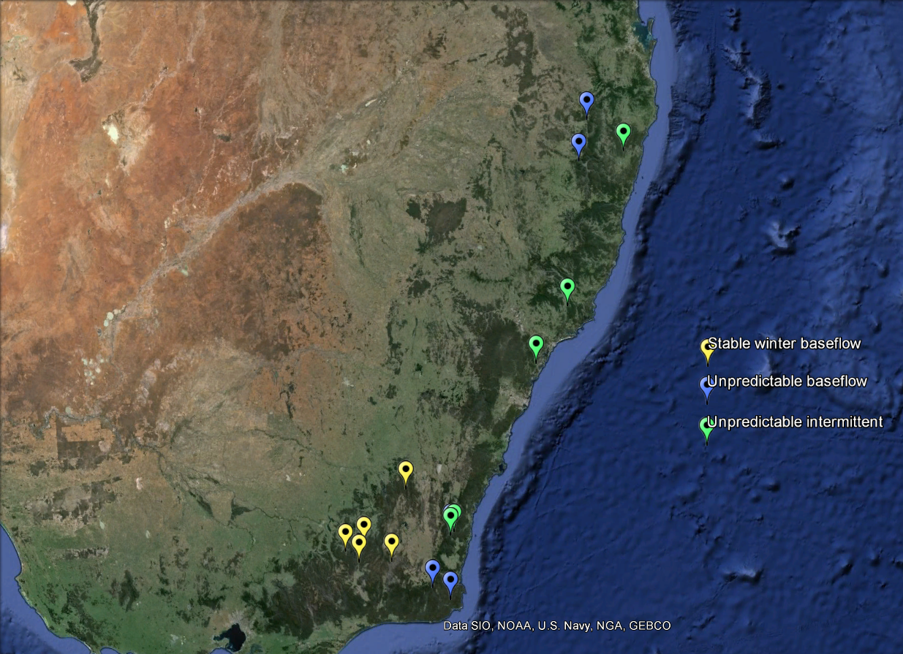

Figure 1. Location of fifteen field study sites across south-eastern Australia chosen to represent the three major hydrological classes of SE Australia.

Gauged locations were selected that had >15 years of associated continuous hydrological data, and an absence of flow regulation, significant water extraction or catchment urbanisation, following Kennard et al. (2010). To minimise signals associated with human land-use and river type, the following further criteria were used to shortlist possible study sites: all were partly confined valleys with discontinuous floodplain pocket River Styles (c.f. Brierley and Fryirs, 2005), had an intact native riparian vegetation cover (a band of native riparian vegetation extending >15 m from the channel edge), were in good geomorphic condition (lack of significant human-induced erosional or depositional landforms), minimal vegetation clearing (catchment predominantly covered by native vegetation) and occurred in a catchment smaller than 1000 km2 . These criteria were assessed using a combination of visual inspection of satellite photography (Google Earth, Microsoft Bing), and information from the NSW Riparian Vegetation Extent dataset and the NSW Office of Water River Styles® geospatial dataset (NSW Office of Water, Department of Primary Industries). To select the 15 study sites from this shortlist, accessibility by road, permission from state or private landholders, and proximity of accessible areas to continuous hydrological monitoring stations were taken into account.

**Species abundance and trait data collection**

Data collection was undertaken between December 2012 and May 2013. At each site, a 10 m by 50 m plot was marked out, with the longest edge abutting the channel edge. Criteria for selection of plot locations were: geomorphic homogeneity (the plot comprising only sloping bank where possible) and lack of anthropogenic disturbance such as built structures, roads or tracks, recent logging or clearing (in the last 20-30 years), herbicide spraying or animal grazing.

Proportional cover of woody vegetation was assessed for three strata: shrub (1-4 m), subcanopy (4-8 m) and canopy (>8 m). Species were identified using appropriate field guides, and were verified against specimens at the Macquarie University Herbarium or by staff at the Royal Botanic Gardens, Sydney.

# Wood samples were collected from dominant woody species present within the plot at >5% cover in shrub, sub canopy or canopy strata, and which had trunks robust enough to core. A 100 mm wood sample from each of two individuals per species was extracted using a 5.15 mm diameter, triple threaded increment borer (Haglöf Sweden). Samples were extracted from the base of the main trunk, 10 cm above the leaf litter level, and air-dried at 20-45 °C. On return to the laboratory, samples were rehydrated in deionised water and 10 mm sections of mature wood were cut with a razor, using visual inspection of vessel occlusion as an indicator of maturity. Sections were measured (x, y and z dimensions) with callipers (Mitzuni) to calculate wet volume, then oven-dried at 80°C for 48 hours and weighed using a microbalance (Mettler Toledo). Wood density was then calculated as the ratio of oven dry mass to wet volume (g/cm3).

**Hydrological analysis**

Hydrological data pertaining to each field site were collated from the PINNNENA CW 10.1 database (NSW Office of Water, Department of Primary Industries) and the NSW Office of Water Continuous Water Monitoring network website (<http://realtimedata.water.nsw.gov.au/water.stm>) for NSW sites, and the Victoria State Government’s Water Measurement Information System website (<http://data.water.vic.gov.au/monitoring.htm>) for Victorian sites. Daily discharge rate data is recorded as timestamped average daily flow datapoints in units of megalitres per day. Where possible 30 year time series were obtained, spanning years 1983 – 2012. Records were truncated for three sites, spanning 15, 19 and 28 years. Missing data were approximated using the Time Series Manager module in River Analysis Package (REF). Consistency of the resulting outputs were checked by visual inspection of hydrographs. For Mammy Johnson’s River, Mann River, Sportsman’s Creek and Wallagaraugh River, multiple linear regression was chosen as the most appropriate method. Linear interpolation was used for Jilliby Creek data.

A set of XXXXX hydrological metrics was pared from the full set described by Kennard et al. (2010). These metrics were chosen to be representative of variability in high flow magnitude and frequency as well as predictability and consistency of water availability in the riparian environment (see Table 1 for a description). We used the Time Series Analysis module in River Analysis Package to generate these metrics. Means and coefficients of variation were calculated for most metrics to indicate central tendency as well as spread within the data. Low and high spell metrics were thresholded at the 5th and 95th percentiles, respectively, with a flood independence criterion of 7 days between peaks events. Twenty year average return interval (ARI) flood magnitude was also calculated with a flood independence value of 7 days between peaks. Colwell’s Indices were calculated using mean values over monthly time periods and a class distribution of 11 flow classes. Metrics of flow magnitude were normalised by mean daily flow to allow for comparison between different sizes of river.

|  |  |  |  |  |
| --- | --- | --- | --- | --- |
| **Parameter** | **Abbreviation** | | **Units** | **Description** |
| *Flood frequency and magnitude* | | | | |
| Mean magnitude of high spells* | HSPeaknorm | dimensionless | | High spells are periods of flow above the 95th percentile on the flow duration curve. We were interested in how frequently these conditions occurred over the time series as well as the mean magnitude of peak flows during these periods. 20 year average return interval (ARI) floods are extreme flow events that have the potential to re-work the fluvial landscape. Together, these metrics indicate the intensity and frequency of mechanical stress experienced by plants in the riparian zone. |
| CV of all years’ mean high spell magnitude | CVAnnHSPeak | dimensionless | |
| 20 year ARI flood magnitude* | AS20YrARInorm | dimensionless | |
| Mean of all years’ number of high spells | MDFAnnHSNum | year-1 | |
| CV of all years’ number of high spells | CVAnnHSNum | dimensionless | |
| *Rise and fall rates* | | | | |
| Mean rate of rise * | MRateRisenorm | dimensionless | | Rise and fall rates represent flow ‘flashiness’. Fast rise rates are associated with flood waves and intense mechanical stress to plant stems. Slow fall rates keep exposed substrate moist for longer periods, which may produce favourable conditions for germination. Historical discharge records are unfortunately limited to daily resolution, so are unable to fully capture flood discharge shapes. High variability between years indicates the occurrence of extreme events which may not have been captured by the mean value. |
| Mean rate of fall * | MRateFallnorm | dimensionless | |
| CV of all years mean rate of rise | CVAnnMRateRise | dimensionless | |
| CV of all years mean rate of fall | CVAnnMRateFall | dimensionless | |
| *Baseflow index* | | | | |
| Baseflow index | BFI | dimensionless | | Baseflow index is calculated using the ratio of flow during average conditions to total flow. It is a useful metric of consistency of water availability, in that it is maximised when average flow conditions dominate, and minimised when total flow is dominated by above average flow events. Intra-annual variability in baseflow index measures how predictable baseflow index is between years. |
| CV of all years Baseflow Index | CVAnnBFI | dimensionless | |
| *Low flow magnitude, frequency and duration* | | | | |
| CV of all years’ mean low spell magnitude | LSPeaknorm | dimensionless | | Low spells are periods of flow below the 5th percentile on the flow duration curve. We were interested in how frequently these conditions occurred over the time series as well as the mean and interannual variability in magnitude and duration of low flows. |
| CV of all years’ mean of low spell magnitude | CVAnnLSPeak | dimensionless | |
| Mean of all years’ number of low spells | MDFAnnLSNum | year-1 | |
| CV of all years’ number of low spells | CVAnnLSNum | dimensionless | |
| Mean duration of low spells | LSMeanDur | days | |
| CV of all years’ low spell mean duration | CVAnnLSMeanDur | dimensionless | |
| Mean flow during driest week of the year* | MA.7daysMinMeannorm | dimensionless | |
| Mean days per year under 0.1ML/day flow | MDFAnnUnder0.1 | days/year | |
| CV of all years’ days per year under 0.1ML/day flow | CVAnnMDFAnnUnder0.1 | dimensionless | |
| *Colwell’s indices* | | | | |
| Constancy of monthly mean daily flow | C_MDFM | dimensionless | | Colwell’s indices provide a measure of the seasonal predictability of flow events and therefore water availability within the riparian zone. Constancy (M) measures uniformity of flow across seasons, and is maximised when flow conditions do not differ between seasons. Contingency (M) is a measure of interannual uniformity in seasonal flow patterns, and is maximized when seasonal patterns of flow are consistent between years.  We generated Colwell’s indices for both average flow conditions and minimum flows conditions. |
| Contingency of monthly mean daily flow | M_MDFM | dimensionless | |
| Constancy based on monthly minimum daily flow | C_MinM | dimensionless | |
| Contingency based on monthly minimum daily flow | M_MinM | dimensionless | |

Table 1. Hydrological parameters used as metrics of variability in high flow magnitude and frequency and predictability and consistency of water availability in the riparian environment. * - normalised by mean daily flow (ML/day)

Finally, we performed permutational multivariate analysis of variance using distance matrices, using the vegan package in R (Oksanen et al., 2013; R Core Team, 2013) across these chosen metrics to assess whether our field sites comprise three significantly different hydrological categories.

**Data analysis**

All statistical analyses were performed using the R statistical programming environment (R Core Team, 2013). Statistical significance was thresholded at alpha = 0.05.

*Abundance weighted site means of wood density*

To investigate variation in wood density across hydrological gradients at the community level, abundance weighted means of wood density were generated for each site. Species relative abundance was compiled from records of % cover at the shrub (1-4 m), subcanopy (4-8 m) and canopy (8+ m) strata. Wood density values were then weighted according to species relative abundance and then summed to produce the abundance weighted site mean. This method integrates particular trait values with their real world abundance as a measure of ‘performance’, while providing a useful reduction in data dimensionality. Wood density varies only over one order of magnitude, while exhibiting relatively high intra-species plasticity. As such, abundance weighted site means work well for environmental gradient studies because the focus is maintained on the functional characteristics of the community, rather than on species *per se*.

*Comparing wood density between hydrological classes*

Raw species trait values were lumped according to the hydrological class membership, and differences between classes tested using a post-hoc Tukey’s HSD test. This test was repeated using class-lumped abundance weighted site means.

*Testing relationships between mean wood density and hydrological conditions*

Ordinary least-squares regression models were generated for selected metrics to determine relationships between hydrological gradients and abundance weighted site mean values. Wood density data was normally distributed and did not require transformation. To reduce the occurrence of Type 1 statistical error, we adjusted the resulting p values using the Benjamini - Hochberg (BH) procedure for controlling family-wise error rate (stats package, R Core Team 2013). Although ecological rationale supported inclusion of each subgroup of hydrological metrics, these metrics were highly autocorrelated. The BH procedure has been shown to control the false discovery rate for positively dependent test statistics (Benjamini and Yekutieli, 2001). We then identified ecologically relevant axes of variation in hydrological conditions by running a principal components analysis (stats package, R Core Team 2013) for the hydrological metrics showing significant relationships with site mean wood density values.

**Results**

*Confirmation of hydrological classes*

The three hydrological classes of river in this study were significantly different across the XX chosen hydrological metrics. Stable baseflow rivers were most different from unpredictable intermittent rivers, R2 = 0.644, and slightly less so from unpredictable baseflow rivers, R2 = 0.617. Unpredictable intermittent and unpredictable baseflow rivers exhibited greatest similarity, R2 = 0.379.

*Differences in wood density between hydrological classes*

Using abundance weighted site mean values, wood density was found to be significantly different between unpredictable baseflow rivers and stable baseflow rivers. The difference between unpredictable intermittent rivers and stable baseflow rivers approached significance (p = 0.052), indicating that differences in wood density between classes of river relates to differences in hydrology. No significant difference in raw wood density values was found between hydrological classes.

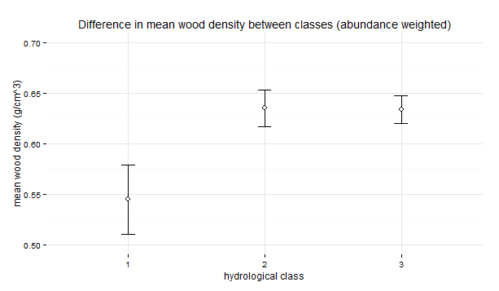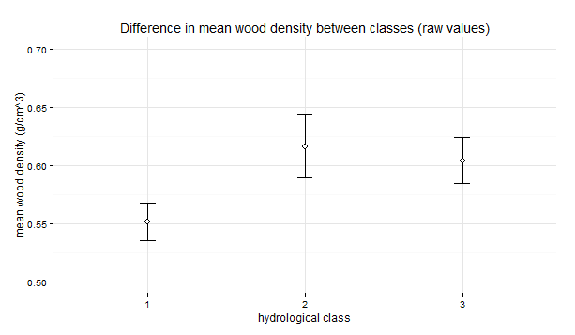

Figure 2. Comparison of mean wood density between hydrological classes using a) abundance weighted means, b) means of raw wood density values. Error bars represent standard error of the mean.

*How does wood density change over hydrological gradients?*

Metrics describing the largest, most intense flood events throughout a river’s hydrological record were found to be strong positive predictors of mean wood density (Fig 3c,d,e). Flooding frequency had no influence on wood density. Interannual variability (Fig 3d) in flood magnitude did not show a significant relationship with wood density after Benjamini-Hochberg adjustment, although a trend was apparent. Removing the Snowy Creek site as an outlier, due to its high mean wood density (0.66 g/cm3) relative to other stable winter baseflow sites, produced a tight relationship (R2 = 75.4, p > 0.001). Variability in flood rise and fall rates (Fig3a,b) were also significant positive predictors of wood density, while mean flood rise and fall rates showed no significant relationship. These results indicate that large flow events not captured by the mean are driving the observed patterns of wood density.

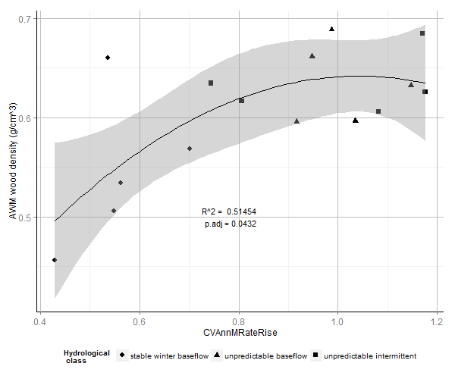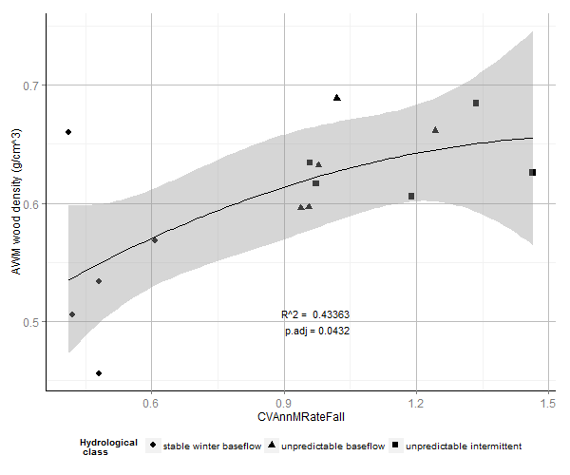

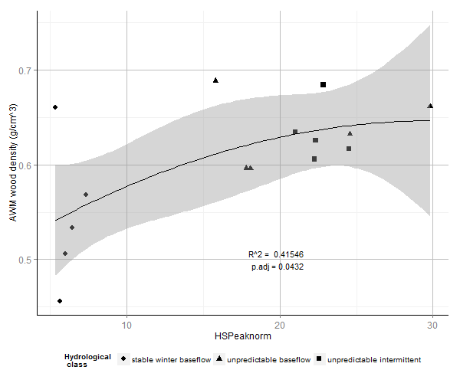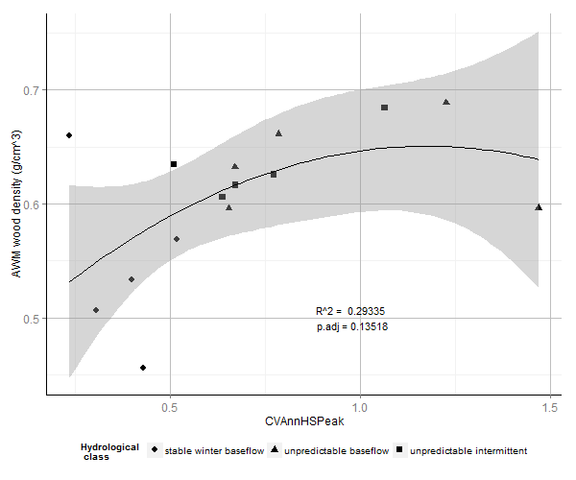

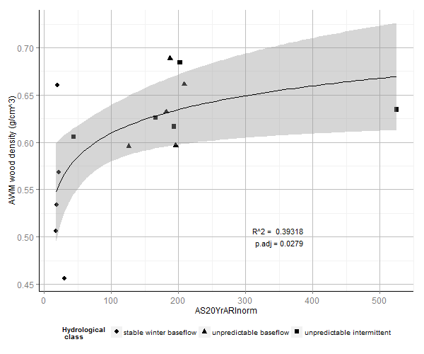

Figure 3. Relationships between abundance weighted mean wood density and hydrological metrics describing a) interannual variability in flood rise? rates (CVAnnMRateRise), b) interannual variability in flood fall? rates (CVAnnMRateFall), c) mean high flow magnitude (HSPeaknorm), d) interannual variability in high flow magnitude (CVAnnHSPeak), e) magnitude of the 20 year average return interval flood (AS20YrARInorm). Fitted lines depict ordinary least squares regression models. a. – d. are quadratic fits, e. is an exponential fit. Shaded areas depict the smoothed 95% confidence interval around the regression model. p.adj refers to Benjamini-Hochberg adjusted p values.

We found denser woody tissues were increasingly favoured as baseflow index decreased (Fig 4a). Wood density increased as patterns of average flow conditions became a) less uniformly distributed across seasons (Fig 4c), and b) less uniformly distributed year to year (Fig 4d). Thus mean wood density is maximised when average flow patterns are highly seasonal, but the season with which they are associated is not consistent throughout the record. A similar relationship was observed for inter-annual (Fig 4e) but not inter-seasonal uniformity of minimum flows. In other words, it was not important how strongly minimum flows were associated with particular seasons, but whether the seasonal pattern of flows was the same across years of the record. Mean wood density also increased with increasing interannual variability in baseflow index (Fig 4b), pointing to a strong effect from years in which baseflow deviated from the mean. Wood density also decreased with mean low spell flow (Fig 4f), and with the mean 7 day minimum flow (after removal of Snowy Creek as an outlier) (Fig 4g). For both metrics higher values indicate wetter minimum flow conditions. Metrics of low flow duration were not significantly associated with wood density.

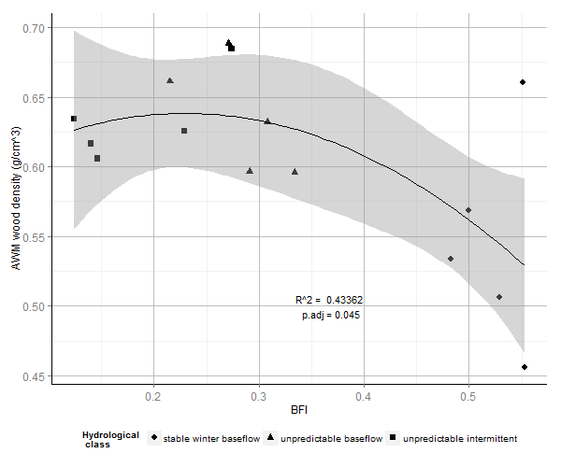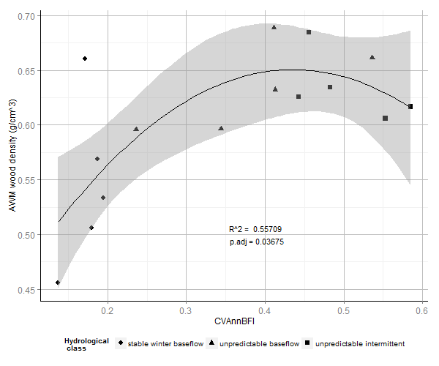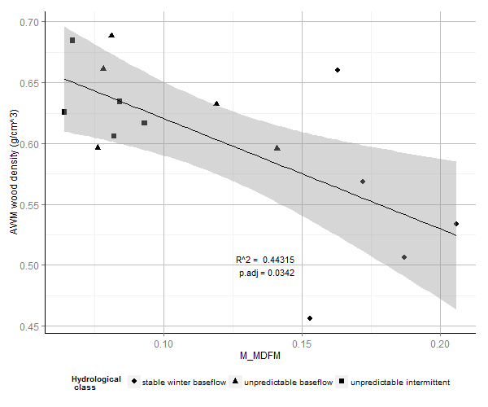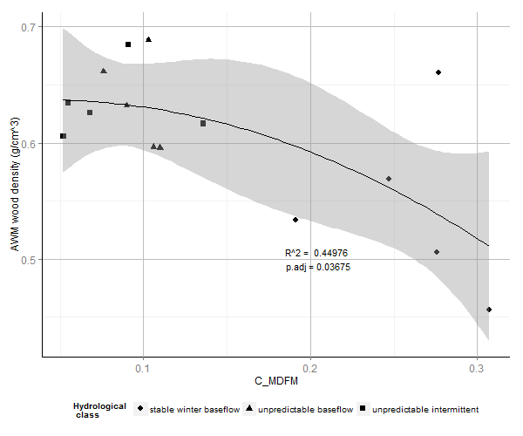

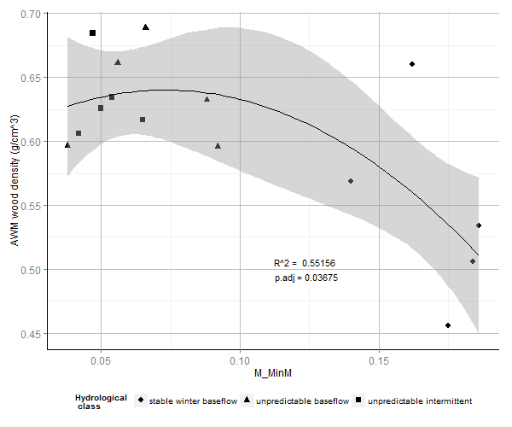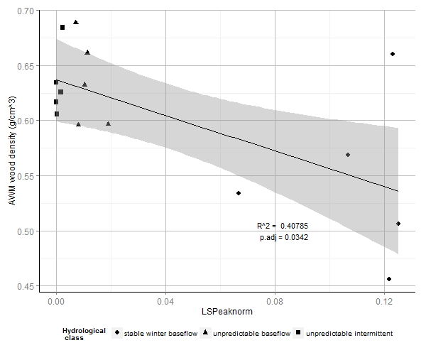

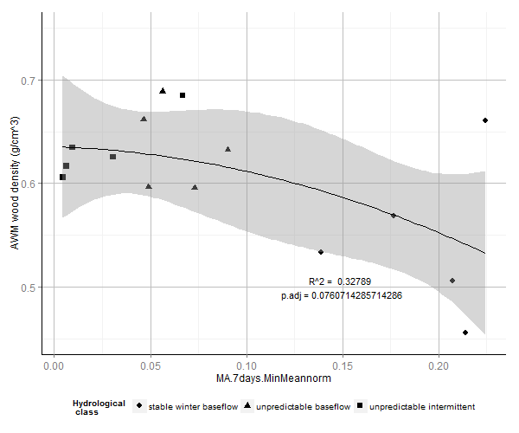

Figure 4. Relationships between abundance weighted mean wood density and hydrological metrics describing a.) baseflow index (BFI), b.) interannual variability in baseflow index (CVAnnBFI), c.) contingency of monthly mean daily flow (M_MDFM), d.) contingency of monthly mean daily flow (C_MDFM), e.) contingency of monthly minimum daily flow (M_MinM), f.) mean low flow magnitude (LSPeaknorm), g.) Mean flow during driest week of the year (MA.7days.MinMeannorm). Shaded areas depict the 95% confidence interval around the regression model. p.adj refers to Benjamini-Hochberg adjusted p values.

|  |  |  |  |  |  |  |
| --- | --- | --- | --- | --- | --- | --- |
|  | All values included | |  | Snowy Creek value removed | | |
| *Metric* | *p* | *p.adj* | *R2* | *p* | *p.adj* | *R2* |
| M_MinM | 0.0038 | 0.0432 | 0.552 | 0.0002 | 0.0008 | 0.740 |
| CVAnnBFI | 0.0064 | 0.0432 | 0.557 | 0.0001 | 0.0007 | 0.838 |
| CVAnnMRateRise | 0.0068 | 0.0432 | 0.515 | 0.0001 | 0.0007 | 0.787 |
| M_MDFM | 0.0094 | 0.0432 | 0.443 | 0.0018 | 0.0039 | 0.606 |
| C_MDFM | 0.0098 | 0.0432 | 0.450 | 0.0001 | 0.0007 | 0.758 |
| CVAnnMRateFall | 0.0117 | 0.0432 | 0.434 | 0.0001 | 0.0007 | 0.783 |
| AS20YrARInorm | 0.0124 | 0.0279 | 0.393 | 0.0057 | 0.0114 | 0.668 |
| LSPeaknorm | 0.0128 | 0.0432 | 0.427 | 0.0002 | 0.0008 | 0.724 |
| HSPeaknorm | 0.0144 | 0.0432 | 0.415 | 0.0005 | 0.0013 | 0.708 |
| BFI | 0.0180 | 0.0480 | 0.434 | 0.0001 | 0.0007 | 0.816 |
| MA.7daysMinMeannorm | 0.0355 | 0.0852 | 0.328 | 0.0003 | 0.0009 | 0.755 |
| CVAnnHSPeak | 0.0751 | 0.1502 | 0.293 | 0.0017 | 0.0039 | 0.754 |
| MRateRisenorm | 0.1631 | 0.2899 | 0.348 | 0.0730 | 0.1348 | 0.528 |
| CVAnnHSNum | 0.1691 | 0.2899 | 0.164 | 0.2300 | 0.3450 | 0.135 |
| MDFAnnLSNum | 0.1908 | 0.3053 | 0.208 | 0.2600 | 0.3671 | 0.183 |
| MRateFallnorm | 0.2098 | 0.3061 | 0.283 | 0.1100 | 0.1886 | 0.443 |
| CVAnnLSPeak | 0.2168 | 0.3061 | 0.245 | 0.1500 | 0.2400 | 0.339 |
| LSMeanDur | 0.4115 | 0.5487 | 0.180 | 0.4300 | 0.5280 | 0.159 |
| CVAnnLSNum | 0.4417 | 0.5579 | 0.052 | 0.4400 | 0.5280 | 0.054 |
| C_MinM | 0.4919 | 0.5903 | 0.259 | 0.3700 | 0.4933 | 0.427 |
| MDFAnnUnder0.1 | 0.5904 | 0.6747 | 0.071 | 0.5100 | 0.5829 | 0.105 |
| MDFAnnZer | 0.6360 | 0.6938 | 0.092 | 0.5600 | 0.6109 | 0.130 |
| MDFAnnHSNum | 0.6885 | 0.7184 | 0.262 | 0.8100 | 0.8100 | 0.254 |
| CVAnnLSMeanDur | 0.8483 | 0.8483 | 0.029 | 0.6700 | 0.6991 | 0.028 |

Table 2. Statistics for regression models comparing hydrological metrics with site mean wood density. Statistics for models where Snowy Creek was removed as an outlier are also given. The initial best fit for AS20YrARInorm was an exponential model, but after removal of Snowy Creek, values are given for a quadratic model which gave a better fit. The model for MA.7daysMinMeannorm was made non-significant after p-value adjustment, but returned to significance following outlier removal. CVAnnHSPeak was non-significant initially but a significant relationship became apparent following outlier removal.

To summarise, we found evidence that mean riparian wood density is positively related to flood magnitude and extremes in flow rise and fall rates, as well as to unpredictability in flow conditions over daily, seasonal and annual timescales. Strong relationships with measures of interannual variability point to years in which the environment was extreme as powerful selectors for high wood density. Patterns of class-wise clustering were generally maintained across continua of specific hydrological gradients. Relationships were described best by quadratic or exponential models, indicating a saturation point above which variation in hydrology ceases to be associated with changes in mean wood density. While not presented in the main text due to data limitations, we also found that for some species, intraspecific variation in wood density responded strongly to hydrology. The reader may refer to the supplementary information for specifics. Removing Snowy Creek as an outlier value substantially tightened up relationships between wood density and hydrological metrics (see Table 2). This site was located within Victoria State Forestry and appeared to have been cleared by logging within the last 20-30 years. Compared with upstream reaches within National Parks land, seral scrubs of dense stemmed *Leptospermum spp.* were considerably more abundant, which may account for this discrepancy.

*What are the principal components of variation in hydrological conditions that predict wood density?*

Hydrological metrics that significantly explained site mean wood density were highly autocorrelated in our dataset. Principal Components Analysis (PCA) identified one dominant axis within these metrics, representing 84% of variation. The remaining variation was split between several minor axes.

|  |  |  |  |  |  |  |  |  |  |
| --- | --- | --- | --- | --- | --- | --- | --- | --- | --- |
|  | PC1 | PC2 | PC3 | PC4 | PC5 | PC6 | PC7 | PC8 | PC9 |
| Standard deviation | 2.8961 | 0.85829 | 0.55727 | 0.52554 | 0.3549 | 0.25338 | 0.21775 | 0.1683 | 0.1342 |
| Proportion of variance | 0.8387 | 0.07367 | 0.03106 | 0.2762 | 0.0126 | 0.00642 | 0.00474 | 0.00283 | 0.0018 |
| Cumulative proportion | 0.8387 | 0.9124 | 0.94346 | 0.97108 | 0.9837 | 0.9909 | 0.99483 | 0.99767 | 0.9995 |

Table 3. Variation in hydrological conditions across principal component axes. PC axes shown in Fig 5 are highlighted.

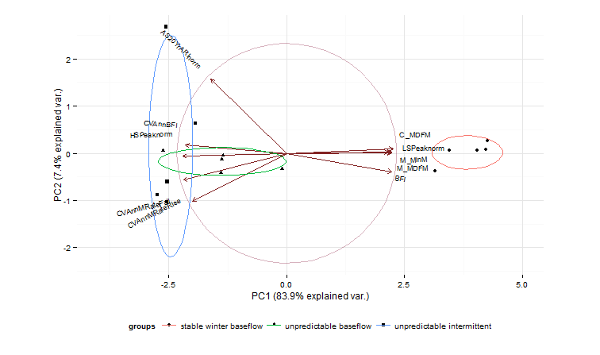

Figure 5. Biplot of sites ordinated across the first two principal components (PC) of the PCA. Points represent positions of individual sites. Ellipses indicate clustering of sites according to hydrological class. Arrows represent loadings of hydrological metrics across each PC.

PC1 represents a gradient of environmental harshness that integrates baseflow characteristics, seasonality and flooding intensity. Metrics which are maximised under conditions of weak seasonality, high predictability and low variability of water availability were positioned at the positive end of the PC1 axis, while metrics that are maximised under conditions of interannual high baseflow variability and high intensity flooding were positioned at the negative end. Stable baseflow rivers exhibited lower site mean wood density, and were clustered at the ‘mild’ positive end of the PC1 gradient. Unpredictable baseflow and unpredictable intermittent rivers overlapped across PC1 and were located distally towards the ‘harsh’ negative end, and were associated with higher site mean wood density. The results of the PCA analysis confirmed the pattern of differentiation in wood density between hydrological classes, and illustrated that variation in wood density is largely described by a single axis of variation from low to high variability in flow.

**Discussion**

These results lend credibility to broad-scale ecohydrological classification as a coarse but useful tool in understanding riparian functional ecology. Where river systems belong to different hydrological classes but are spatially or climatically close, it makes sense to dig deeper than lumped categorical comparisons and compare continuous hydrological parameters.

We found that wood density increased with intensity of flooding disturbance. Wood density was not correlated with the frequency of high flow periods, which individually may not correspond to significant disturbance events, depending on the hydrological characteristics of the given river. Rather, it was the actual magnitude of flow during high flow periods that was important. The observation that variability but not average values of flood rise and fall rates was associated with wood density, indicates the influence of low frequency, intensely flashy outlier flow events not captured by the mean as important hydrological drivers. A pattern is apparent then, in which wood density in riparian communities is driven by powerful but relatively rare flow events. The abundance of high wood density strategies in these environments indicates that infrequent but high-stakes events are a greater force of selection in riparian plant communities than average conditions. Intriguingly, it also suggests that selection is taking place on the adult stage rather than on seedlings. We therefore suggest that a ‘brick house’ ecological strategy is selected for in riparian environments that experience intense flooding. This suggestion concurs with findings that trees on windy slopes tend to overcompensate for mechanical stress, with investment in defences increasing cumulatively in response to rare, extreme events (Cohen & Mangel 1999, Telewski 1995).

Mean wood density was also strongly associated with predictability of water availability in the riparian zone . We can extend the observation about the influence of intense ‘pulse’ flow events on wood density: plants living in environments where flow occurs unpredictably and largely within specific events, rather than being evenly distributed throughout time, are likely to experience more intense pulses of water stress.

High wood density may be symptomatic of wood anatomy strategies that allow plants to tolerate water stress (Hacke, Sperry, Pockman, Davis, & McCulloh, 2001; A. Jacobsen & Ewers, 2005; A. L. Jacobsen et al., 2007). Numerous studies have discussed the role of various anatomical components of woody tissue in stabilising xylem against cavitation when plants are under severe water stress, but the exact role that woody fibres play in stabilising xylem vessels appears to be inconsistent (Martínez-Cabrera et al., 2009). Overall, resistance against cavitation appears to result from complex interactions between wood anatomical traits (Lens et al., 2011; Zieminska, Butler, Gleason, Wright, & Westoby, 2013) and/or aboveground biomass production traits, both of which are tangentially related to wood density. Barring ephemeral dryland rivers, most riparian environments are not usually highly water stressed, so specifically constructing woody tissue to deal with constant water stress may not be advantageous. For plants that are habituated to plentiful soil moisture, however, having no backup strategy for surviving drought conditions may be risky.

A more compelling rationale for our findings is that riparian woody plants are again overcompensating for the possibility of rare, life-or-death stress events. In the absence of predictable cues about timing of watering flows, broad phenotypic plasticity in resource use traits may in fact be maladaptive in highly unpredictable environments (Valladares, Balaguer, Martinez-Ferri, Perez-Corona, & Manrique, 2002; Valladares, Chico, & Aranda, 2002) and conservative resource-use phenotypes such as higher wood density would be favoured (Valladares et al. 2007). Traits associated with conservative resource use and better recovery following periods of extreme stress actually confer as much or greater fitness than traits associated with tolerating the event itself, such as thermotolerance (Gutschick & BassiriRad, 2003).

Conservative resource use and heavy investment in structural strength fit within the ‘resister’ category of riparian plant strategies described by Naiman & Decamps' (1997) classification of riparian plant life history strategies. ‘Invader’ strategies in which species avoid harsh hydrological conditions by achieving sexual maturity as fast as possibleare also common to the riparian environment (Naiman & Decamps, 1997; Woolfrey & Ladd, 2001). Pioneer species employing a fast relative growth rate, low wood density ecological strategy would be benefitted by repeated setbacks to early successional conditions (Westoby, 1998). Abundance weighted means may obfuscate the true pattern where differentiation in ecological strategy is strong, due to their inability to capture multimodality in trait distributions. In this case, greater abundance of these species would drive down mean wood density values through the upper ranges of disturbance intensity. This observation offers a potential explanation for the goodness of fit of quadratic models which begin to dip after reaching an apex at three quarters of their maximum value, rather than simply approaching an asymptote (e.g. Fig 3a,d, Fig 4a,b,d). It is difficult to substantiate this suggestion using our dataset, however, as only a few datapoints are present in the upper ranges of disturbance intensity.

Another mechanism for coping with harsh conditions is possible. Some species also have the ability to radically change their wood density throughout their life history. *Casuarina cunnhinghamiana*, for instance, is an obligate riparian species whose entire life history revolves around response to flooding disturbance. After seeding *en masse* onto fresh substrate within or close to the river channel (an ‘invader’ strategy), dense stands of flexible-stemmed saplings emerge, protecting each other from flood flows (Woolfrey & Ladd, 2001). Self-thinning subsequently occurs, and measurements from adult plants indicate thatstem wood density increases during maturation; the plant has metamorphosed towards the ‘resister’ phenotype. This change in strategy is likewise difficult to capture using abundance weighted means.

Under our argument, where hardy rheophytic species use high wood density ecological strategies to cope with powerful floods and unpredictable watering regimes, we would expect species such as *Casuarina cunninghamiana* and *Tristaniopsis laurina* to have the highest wood density in our dataset. Both species exhibit highly variable trait values, however, ranging approximately between the median value and the 75th percentile. As with *C. cunninghamiana,* *T. laurina* is a heliophilc coloniser of within and near-channel landforms (Webb, Erskine, & Dragovich, 2002). By establishing so close to the channel, seedlings of these species must balance the risks of flooding with the advantages of growth unencumbered by competition for light or space. Maintaining a high relative growth rate, at least until the trees are physically large enough to endure flooding, allows these species to quickly fill space and build photosynthetic tissue (Melick, 1990). If parallels with tropical rainforest species hold (King et al., 2006; N. Kraft, Valencia, & Ackerly, 2008; L Poorter et al., 2008; Lourens Poorter et al., 2010; Wright et al., 2010), however, this strategy will not be conducive to setting down dense wood. In addition to morphological adaptations in *T. laurina* such as multi-stemmedness, narrow leaves and growth streamlined against the direction of flow (van Steenis, 1981; Webb et al., 2002), the trade-off between flood resistance and rapid resource acquisition during establishment serves to explain why the optimal wood density for rheophytic species occurs in a middling position on the ladder of wood density. Instead, it is the tall, facultative riparian species from rainforest sites that occupy the highest rungs in our dataset. **This observation agrees with previous literature showing increasing in wood density along a successional gradient; these species tended to occur further up the bank, so would have been subject to only the most intense flooding events.** Nevertheless, the wide plasticity in wood density shown by *C. cunninghamiana* and *T. laurina* gives headroom for intraspecific variation to track hydrological gradients.

WOOD DENSITY LIT PARAGRAPH

* Life history strategies – probably the most important tie in with the existing literature
  + Wood density negatively correlated with growth rate
  + Cohort survival correlated with wood density in tropical rainforests
  + Successional gradient / plant height etc. (big euc spp. have the highest WD)
* Disturbance… (resprouting was important in QLD study, but here it’s rheophyte adaptations). Can’t really say much using my study though, as I don’t have before/after.
* precipitation gradients?
* Unpredictability? Added something here… although hard to tease out..

The gradient identified by principal components analysis integrates predictability of water availability, seasonality and flood intensity into a single axis of hydrological variation. It is not possible to tease out individual drivers of variation in wood density, as the conditions associatedwith both environmental unpredictability and mechanical disturbance act in unison to constrain community wood density to higher mean values. Based on our findings, hydrological regionalisation frameworks that distinguish between rivers according to predictability and perenniality of flow provide a basis for predicting wood density.

Hydrological classification therefore becomes useful in projecting changes to the functional attributes of riparian plant communities under altered flow conditions. In the south-eastern Australian context, changing flow conditions are caused by damming and water extraction, and the changing climate (Australian State of the Environment Committee, 2011). Artificial flow modification by damming and water extraction reduces overall flow volume and the magnitude and frequency of high flow events, while increasing flow predictability, altering seasonality and limiting channel-floodplain connectivity (Graf, 2006; Maheshwari, Walker, & McMahon, 1995). In these altered conditions, terrestrial species with softer wood and faster growth rates may encroach on what was once the province of hardy riparian communities adapted to flooding and less predictable conditions. The converse of this situation is presented by predictions of future climatic conditions: in Australia, warming of 0.4 – 0.7oC has occurred since 1950 (Hennessy et al., 2007), attended by a reduction in rainfall across southern and eastern regions of the continent (Smith, 2004), and an increase in intensity and frequency of droughts (Hennessy et al., 2008). Extreme rainfall events are predicted to become more prevalent, even In areas where the trend is towards mean reductions in annual or seasonal rainfall (Chiew et al., 2009). **AUSTRALIAN RIVERS SENSITIVE TO CLIMATE VARIABILITY, AND** Overall, climate change projections highlight increasing climatic variability and unpredictability, and intensification of the ENSO phenomenon that is an integral driver of eastern Australia’s climate patterns (Hennessy et al., 2008). Under such conditions, diversity of the more opportunistic, facultative riparian species may decline in favour of rheophytic species whose ecological strategies are optimized to harsh hydrological conditions. If changes in spatial extent of climate zones can be related to changes in runoff - a complicated, but progressing area of research in hydroclimatology (M. C. Peel & Bloschl, 2011) – functional approaches to ecohydrology can give insight into the likely changing ecology of riparian plant communities.

Our study emphasises the importance of hydrological conditions, particularly disturbance and environmental unpredictability, as determinants of ecological strategy in riparian plant communities. This is likely to have important ecological consequences for riparian plant communities in this setting, where increasing climatic variability and frequency of extreme events are hallmarks of climate change predictions. and may produce an analogue for conditions that could occur in other settings where hydrological changes associated with human-disturbance or climate change.

**References**

Arthington, A., Mackay, S., James, C., Rolls, R., Sternberg, D., A, B., & SJ, C. (2012). Ecological limits of hydrologic alteration: a test of the ELOHA framework in south-east Queensland, (75). Retrieved from http://nwc.gov.au/__data/assets/word_doc/0016/21724/Waterlines-75-Ecological-limits-of-hydrologic-alteration.doc

Augspurger, C. K., & Kelly, C. K. (1984). Pathogen mortality of tropical tree seedlings: experimental studies of the effects of dispersal distance, seedling density, and light conditions. *Oecologia*, *61*(2), 211–217. doi:10.1007/BF00396763

Australian State of the Environment Committee. (2011). Australian State of the Environment Report - Inland Waters.

Catford, J. a., Naiman, R. J., Chambers, L. E., Roberts, J., Douglas, M., & Davies, P. (2012). Predicting Novel Riparian Ecosystems in a Changing Climate. *Ecosystems*, *June*, 1–19. doi:10.1007/s10021-012-9566-7

Chave, J., Coomes, D., Jansen, S., Lewis, S. L., Swenson, N. G., & Amy, E. (2009). Towards a worldwide wood economics spectrum. *Ecology Letters*, *12*(4), 351–366. doi:10.1111/j.1461-0248.2009.01285.x

Chiew, F. H. S., Teng, J., Vaze, J., Post, D. a., Perraud, J. M., Kirono, D. G. C., & Viney, N. R. (2009). Estimating climate change impact on runoff across southeast Australia: Method, results, and implications of the modeling method. *Water Resources Research*, *45*(10), 1–17. doi:10.1029/2008WR007338

Coley, P. (1983). Herbivory and defensive characteristics of tree species in a lowland tropical forest. *Ecological Monographs*, *53*(2). Retrieved from http://www.esajournals.org/doi/abs/10.2307/1942495

Corenblit, D., Steiger, J., Gurnell, A. M., Tabacchi, E., & Roques, L. (2009). Control of sediment dynamics by vegetation as a key function driving biogeomorphic succession within fluvial corridors. *Earth Surface Processes and Landforms*, *1810*, 1790–1810. doi:10.1002/esp

Cornelissen, J. H. C. A., Lavorel, S. B., Garnier, E. B., Díaz, S. C., Buchmann, N. D., Gurvich, D. E. C., … Poorter, H. I. (2003). A handbook of protocols for standardised and easy measurement of plant functional traits worldwide. *Australian Journal of Botany*, *51*(4), 335–380.

Curran, T. J., Gersbach, L. N., Edwards, W., & Krockenberger, A. K. (2008). Wood density predicts plant damage and vegetative recovery rates caused by cyclone disturbance in tropical rainforest tree species of North Queensland, Australia. *Austral Ecology*, *33*(4), 442–450. doi:10.1111/j.1442-9993.2008.01899.x

Falster, D. S. (2006). Sapling strength and safety: the importance of wood density in tropical forests. *The New Phytologist*, *171*(2), 237–9. doi:10.1111/j.1469-8137.2006.01809.x

Falster, D., & Westoby, M. (2005). Alternative height strategies among 45 dicot rain forest species from tropical Queensland, Australia. *Journal of Ecology*, *93*, 521–535. doi:10.1111/j.1365-2745.2005.00992.x

Finlayson, B. L., & McMahon, T. A. (1988). Australia vs. the world: a comparative analysis of streamflow characteristics. *Fluvial Geomorphology of Australia*, 17–40.

Graf, W. (2006). Downstream hydrologic and geomorphic effects of large dams on American rivers. *Geomorphology*, *79*(3-4), 336–360. doi:10.1016/j.geomorph.2006.06.022

Gutschick, V. P., & BassiriRad, H. (2003). Extreme events as shaping physiology, ecology, and evolution of plants: toward a unified definition and evaluation of their consequences. *New Phytologist*, *160*(1), 21–42. doi:10.1046/j.1469-8137.2003.00866.x

Hacke, U. G., Sperry, J. S., Pockman, W. T., Davis, S. D., & McCulloh, K. a. (2001). Trends in wood density and structure are linked to prevention of xylem implosion by negative pressure. *Oecologia*, *126*(4), 457–461. doi:10.1007/s004420100628

Hennessy, K., Fawcett, R., Kirono, D., Mpelasoka, M., Jones, D., Bathols, J., … Plummer, N. (2008). *An assessment of the impact of climate change on the nature and frequency of exceptional climatic events*. Department of Agriculture, Fisheries and Forestry, 2008. Retrieved from http://www.oisaweb.es/documents/10148/30643/Impact+of+climate+change+on+the+nature+of+excepcional+climatic+events.pdf

Hennessy, K., Fitzharris, B., Bates, B. C., Harvey, N., SM, H., L, H., … Warrick, R. (2007). *Climate Change 2007: Impacts, Adaptation and Vulnerability. Contribution of Working Group II to the Fourth Assessment Report of the Intergovernmental Panel on Climate Change*. (M. . Parry, O. . Canziani, J. . Palutikof, P. . van der Linden, & C. . Hanson, Eds.) (pp. 507–540). Cambridge: Cambridge University Press.

Jacobsen, A., & Ewers, F. (2005). Do xylem fibers affect vessel cavitation resistance? *Plant Physiology*, *139*(September), 546–556. doi:10.1104/pp.104.058404.result

Jacobsen, A. L., Agenbag, L., Esler, K. J., Pratt, R. B., Ewers, F. W., & Davis, S. D. (2007). Xylem density, biomechanics and anatomical traits correlate with water stress in 17 evergreen shrub species of the Mediterranean-type climate region of South Africa. *Journal of Ecology*, *95*(1), 171–183. doi:10.1111/j.1365-2745.2006.01186.x

Kattge, J., Díaz, S., Lavorel, S., Prentice, I. C., Leadley, P., Bönisch, G., … Wirth, C. (2011). TRY - a global database of plant traits. *Global Change Biology*, *17*(9), 2905–2935. doi:10.1111/j.1365-2486.2011.02451.x

Kennard, M. J., Pusey, B. J., Olden, J. D., Mackay, S. J., Stein, J. L., & Marsh, N. (2010). Classification of natural flow regimes in Australia to support environmental flow management. *Freshwater Biology*, *55*(1), 171–193. doi:10.1111/j.1365-2427.2009.02307.x

King, D. a., Davies, S. J., Tan, S., & Noor, N. S. M. (2006). The role of wood density and stem support costs in the growth and mortality of tropical trees. *Journal of Ecology*, *94*(3), 670–680. doi:10.1111/j.1365-2745.2006.01112.x

Kraft, N. J. B., Metz, M. R., Condit, R. S., & Chave, J. (2010). The relationship between wood density and mortality in a global tropical forest data set. *The New Phytologist*, *188*(4), 1124–36. doi:10.1111/j.1469-8137.2010.03444.x

Kraft, N., Valencia, R., & Ackerly, D. (2008). Functional traits and niche-based tree community assembly in an Amazonian forest. *Science*, (October), 580–582. Retrieved from http://www.sciencemag.org/content/322/5901/580.short

Lens, F., Sperry, J. S., Christman, M. a, Choat, B., Rabaey, D., & Jansen, S. (2011). Testing hypotheses that link wood anatomy to cavitation resistance and hydraulic conductivity in the genus Acer. *The New Phytologist*, *190*(3), 709–23. doi:10.1111/j.1469-8137.2010.03518.x

Maheshwari, B., Walker, K., & McMahon, T. (1995). Effects of regulation on the flow regime of the River Murray, Australia. *Regulated Rivers: …*, *10*(November 1994), 15–38. Retrieved from http://onlinelibrary.wiley.com/doi/10.1002/rrr.3450100103/abstract

Martínez-Cabrera, H. I., Jones, C. S., Espino, S., & Schenk, H. J. (2009). Wood anatomy and wood density in shrubs: Responses to varying aridity along transcontinental transects. *American Journal of Botany*, *96*(8), 1388–98. doi:10.3732/ajb.0800237

McGill, B. J., Enquist, B. J., Weiher, E., & Westoby, M. (2006). Rebuilding community ecology from functional traits. *Trends in Ecology & Evolution*, *21*(4), 178–85. doi:10.1016/j.tree.2006.02.002

Melick, D. (1990). Regenerative succession of Tristaniopsis laurina and Acmena smithii in riparian warm temperate rain-forest in Victoria, in relation to light and nutrient regimes. *Australian Journal of Botany*, *38*, 111–120. Retrieved from http://www.publish.csiro.au/paper/BT9900111

Merritt, D. M., Scott, M. L., Poff, N. L., Auble, G. T., & Lytle, D. a. (2010). Theory, methods and tools for determining environmental flows for riparian vegetation: riparian vegetation-flow response guilds. *Freshwater Biology*, *55*(1), 206–225. doi:10.1111/j.1365-2427.2009.02206.x

Naiman, R., & Decamps, H. (1997). The ecology of interfaces: riparian zones. *Annual Review of Ecology and Systematics*, *28*, 621–658. Retrieved from http://www.jstor.org/stable/10.2307/2952507

Niklas, K. J., & Spatz, H.-C. (2010). Worldwide correlations of mechanical properties and green wood density. *American Journal of Botany*, *97*(10), 1587–94. doi:10.3732/ajb.1000150

Oksanen, J., Blanchet, F. G., Kindt, R., Legendre, P., Minchin, P. R., O’Hara, R. B., … Wagner, H. (2013). vegan: Community Ecology Package. Retrieved from http://cran.r-project.org/package=vegan

Olden, J. D., & Poff, N. L. (2003). Redundancy and the choice of hydrologic indices for characterizing streamflow regimes. *River Research and Applications*, *19*(2), 101–121. doi:10.1002/rra.700

Peel, M. C., & Bloschl, G. (2011). Hydrological modelling in a changing world. *Progress in Physical Geography*, *35*(2), 249–261. doi:10.1177/0309133311402550

Peel, M., McMahon, T., & Finlayson, B. (2004). Continental differences in the variability of annual runoff-update and reassessment. *Journal of Hydrology*, *295*(1-4), 185–197. doi:10.1016/j.jhydrol.2004.03.004

Poff, N. L., Richter, B. D., Arthington, A. H., Bunn, S. E., Naiman, R. J., Kendy, E., … Warner, A. (2010). The ecological limits of hydrologic alteration (ELOHA): a new framework for developing regional environmental flow standards. *Freshwater Biology*, *55*(1), 147–170. doi:10.1111/j.1365-2427.2009.02204.x

Poorter, L., McDonald, I., Alarcón, A., Fichtler, E., Licona, J.-C., Peña-Claros, M., … Sass-Klaassen, U. (2010). The importance of wood traits and hydraulic conductance for the performance and life history strategies of 42 rainforest tree species. *The New Phytologist*, *185*(2), 481–92. doi:10.1111/j.1469-8137.2009.03092.x

Poorter, L., Wright, S. J., Paz, H., Ackerly, D. D., Condit, R., Ibarra-Manríquez, G., … Wright, I. J. (2008). Are functional traits good predictors of demographic rates? Evidence from five neotropical forests. *Ecology*, *89*(7), 1908–20. Retrieved from http://www.ncbi.nlm.nih.gov/pubmed/18705377

Preston, K. a, Cornwell, W. K., & Denoyer, J. L. (2006). Wood density and vessel traits as distinct correlates of ecological strategy in 51 California coast range angiosperms. *The New Phytologist*, *170*(4), 807–18. doi:10.1111/j.1469-8137.2006.01712.x

R Core Team. (2013). R: A Language and Environment for Statistical Computing. Vienna, Austria. Retrieved from http://www.r-project.org/

Reich, P., & Wright, I. (2003). The evolution of plant functional variation: traits, spectra, and strategies. *International Journal of Plant Sciences*, *164*(May 2003), 146–164. Retrieved from http://www.jstor.org/stable/10.1086/374368

Russo, S. E., Jenkins, K. L., Wiser, S. K., Uriarte, M., Duncan, R. P., & Coomes, D. a. (2010). Interspecific relationships among growth, mortality and xylem traits of woody species from New Zealand. *Functional Ecology*, *24*(2), 253–262. doi:10.1111/j.1365-2435.2009.01670.x

Smith, I. (2004). An assessment of recent trends in Australian rainfall. *Australian Meteorological Magazine*, *53*(3), 163–173. Retrieved from http://citeseerx.ist.psu.edu/viewdoc/download?rep=rep1&type=pdf&doi=10.1.1.222.9449

Swenson, N., & Enquist, B. (2007). Ecological and evolutionary determinants of a key plant functional trait: wood density and its community-wide variation across latitude and elevation. *American Journal of Botany*, *94*(3), 451–459. Retrieved from http://www.amjbot.org/content/94/3/451.short

Valladares, F., Balaguer, L., Martinez-Ferri, E., Perez-Corona, E., & Manrique, E. (2002). Plasticity, instability and canalization: is the phenotypic variation in seedlings of sclerophyll oaks consistent with the environmental unpredictability of Mediterranean ecosystems? *New Phytologist*, *156*(3), 457–467. doi:10.1046/j.1469-8137.2002.00525.x

Valladares, F., Chico, J., & Aranda, I. (2002). The greater seedling high-light tolerance of Quercus robur over Fagus sylvatica is linked to a greater physiological plasticity. *Trees*, *16*(6), 395–403. doi:10.1007/s00468-002-0184-4

Van Steenis, C. G. G. J. (1981). *Rheophytes of the world: an account of the flood-resistant flowering plants and ferns and the theory of autonomous evolution*. Sijthoff & Noordhoff Alphen aan den Rijn, Netherlands.

Webb, A., Erskine, W., & Dragovich, D. (2002). Flood-driven formation and destruction of a forested flood plain and in-channel benches on a bedrock-confined stream: Wheeny Creek, southeast Australia. *International Association of …*, *276*, 203–210. Retrieved from http://books.google.com/books?hl=en&lr=&id=G3CYbzEpWTIC&oi=fnd&pg=PA203&dq=Flood-driven+formation+and+destruction+of+a+forested+flood+plain+and+in-channel+benches+on+a+bedrock-confined+stream+:+Wheeny+Creek+,+southeast+Australia&ots=1dlSjcvkPk&sig=WZUDIFkKAVpNY72hr1oF4V_TcOY

Weimann, M., & Williamson, G. (2002). Geographic variation in wood specific gravity: effects of latitude, temperature and precipitation. *Wood and Fiber Science*, *34*(1), 96–107.

Westoby, M. (1998). A leaf-height-seed (LHS) plant ecology strategy scheme. *Plant and Soil*, *199*(2), 213–227. Retrieved from http://www.springerlink.com/index/H5163540255151QR.pdf

Westoby, M., Falster, D. S., Moles, A. T., Vesk, P. a., & Wright, I. J. (2002). PLANT ECOLOGICAL STRATEGIES: Some Leading Dimensions of Variation Between Species. *Annual Review of Ecology and Systematics*, *33*(1), 125–159. doi:10.1146/annurev.ecolsys.33.010802.150452

Westoby, M., & Wright, I. J. (2006). Land-plant ecology on the basis of functional traits. *Trends in Ecology & Evolution*, *21*(5), 261–8. doi:10.1016/j.tree.2006.02.004

Woolfrey, A. R., & Ladd, P. . (2001). Habitat preference and reproductive traits of a major Australian riparian tree species (Casuarina cunninghamiana). *Australian Journal of Botany*, *49*(6), 705–715.

Wright, S. J., Kitajima, K., Kraft, N. J. B., Reich, P. B., Wright, I. J., Bunker, D. E., … Zanne, A. E. (2010). Functional traits and the growth-mortality trade-off in tropical trees. *Ecology*, *91*(12), 3664–74. Retrieved from http://www.ncbi.nlm.nih.gov/pubmed/21302837

Zieminska, K., Butler, D. W., Gleason, S. M., Wright, I. J., & Westoby, M. (2013). Fibre wall and lumen fractions drive wood density variation across 24 Australian angiosperms. *AoB PLANTS*, *5*, plt046–plt046. doi:10.1093/aobpla/plt046